# Conflict Scenario

## **Review**

### Interpersonal Conflict Management Styles

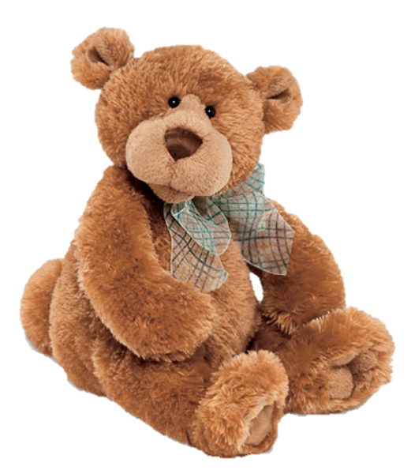

[CC 2.0 BY Matthew](https://www.flickr.com/photos/falcon1961/3304306800/)



[CC SA 3.0 Unported BY Jonathan Zander](https://en.wikipedia.org/wiki/File:Florida_Box_Turtle_Digon3.jpg)



[CC 3.0 BY Superawesomevectors](https://superawesomevectors.deviantart.com/art/Shark-Cartoon-Free-Vector-Illustration-643399222)



[CC0](https://pixabay.com/en/urban-lost-hiding-afraid-1002149/)

Low to High Concern for Other

Concern for Self

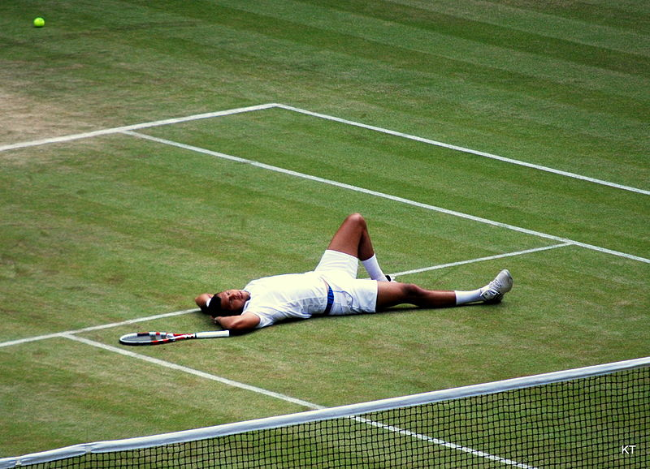

CC SA 2.0 Generic BY [Carine06 from UK](https://commons.wikimedia.org/wiki/File:Flickr_-_Carine06_-_%22I_give_up.%22.jpg)



CC 2.0 BY [Zabara Alexander](https://www.flickr.com/photos/zabara_tango/6955720271)

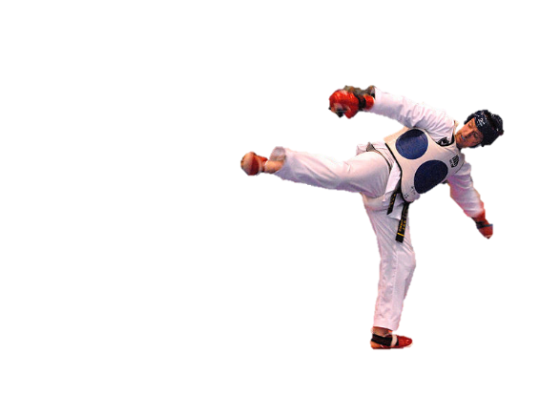

[CC0](https://commons.wikimedia.org/wiki/File:US_Army_53525_Soldiers_compete_in_Tae_Kwon_Do_tournament_for_Warrior_Country_level.jpg)

### **Interpersonal Conflict Resolution**

The following diagram shows a process that can be followed when trying to resolve interpersonal conflict.

### Listening

A considerable proportion of our communication involves listening, yet little attention is devoted to improving listening. HURIER is an acronym for tips that can be used to improve listening.

### “I” Phrases for Conflict Resolution

The “I” phrase is used during conflict resolutions to avoid attacking others. Open the conversation with a statement in first person, passive voice: “I feel … when … because … I would like …”

Adapted from (Dwyer 2012, p. 40)

## **Student Name and ID:** Rutvi 12180614

## **Student Name and ID:** Gourav Kumar 12131664

## **Scenario**

Find a partner. Read the scenario below. Choose one partner to be Joe Bloggs, and the other to be Jane Doe. Together, answer the following to help prepare you for the role play.

## **Scenario: Joe did not complete a task by the deadline**

Joe and Jane are working on a report that is due today. Joe was assigned the task of writing the executive summary. Unfortunately, Joe has not completed the task.

What is the most appropriate conflict management strategy for Jane to use in this situation? (Choose one)

Compete/Force

Compromise

Avoid/Withdraw

Collaborate/Confront

Accommodate/Smooth

Why did you choose the above conflict management strategy?

Collaborate/Confront Strategy as we both wants to complete our report before deadline and this strategy helps us to solve the problem.

### **Listen and Understand**

How could Jane start the conversation?

Jane needs to talk directly with Joe about their problems, why he could not complete his task and what’s the possible solution right now.

Describe the purpose of the discussion. Describe the conflict. What questions could Jane ask to determine Joe’s perspective of the situation?

Main purpose of the discussion is how they are going to complete their report before deadline. They are going to face some difficulties to complete the task as well as they need to ask for some more time to their faculties as well. Jane should ask him about their feeling and opinion regarding report. He going to do his task or not? and any help he need during his task.

Write sentences that features the “I” phrase, such as in the example below:

“I feel *[your feeling]* when *[their behaviour]* because *[effects on you]*. I would like *[alternative behaviour]*”.

I feel tensed when he can’t complete his work because it effects on my mark as well. I would like if he told me this before so I can complete his task for him.

Invent a reason why Joe did not complete the executive summary by the deadline.

Joe has met with an accident last night and he is not well, so he did not complete the task by the deadline.

How could Jane paraphrase Joe’s reason for missing the deadline to ensure that she understands Joe’s perspective?

Jane told joe that she can understand his situation and it’s very difficult to do task in this situation. Also, she told joe that don’t take any stress as they will short this out together.

### **Empathise**

Now that Jane understands Joe’s perspective, how could Jane empathise with Joe? Write a response that shows that Jane identifies with Joe’s emotions.

Jane should ask about his medical condition and help him in their work if he need during this phase. Also, Jane should tell everything to their teacher about Joe condition.

### **Apologise**

Include an apology if it is appropriate.

Yes, Joe should apologies to Jane because her marks and performance effects due to his inconvenience.

### **Offer Solution**

What question could Jane ask to help build Joe’s involvement with potential solutions?

Jane should ask Joe about his opinion and perspective about the report and try to understand each other to do the best for their report.

Come up with a way for Jane and Joe to settle on a solution.

Jane should ask Joe about their speciality and interest in any part of report. So, he can do that part easily and she help them in other parts.

### **Resolution**

How could Jane resolve the conflict? Jane needs to ensure that Joe agrees. Write a response that outlines appreciation for the solution.

Jane handled the situation perfectly by understanding Joe’s condition and help him to complete the task.

### **Reconciliation**

How could Joe reconcile the relationship and let Jane know that she is important to him?

He needs to thank her for understanding his situation and help him to achieve his task. Also, Joe should help her in their other work if she needs.

How can Jane let Joe know she is listening while Joe is talking?

Jane should ask questions about Joe topic and show interest through nonverbal skills like making eye contact when Joe talks.

What could Jane do if Joe started to withdraw from the conflict at any stage?

Jane should try to convince and explain him to achieve his task if his condition is not very serious. But if his condition is very serious then Jane should understand and let him withdraw.